Estimation Project

1. Sensor Noise

Using numpy both files are loaded and standard deviation is calculated in python. The code is located config\log file location named SensorNoise.py.

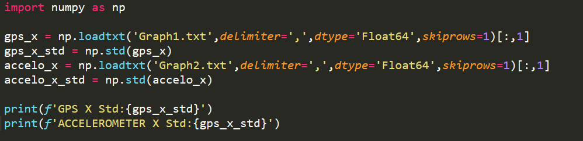

Output:



Input:

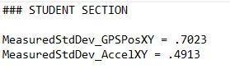

Simulation: 06_ SensorNoise

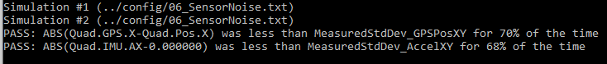

1. Attitude Estimation

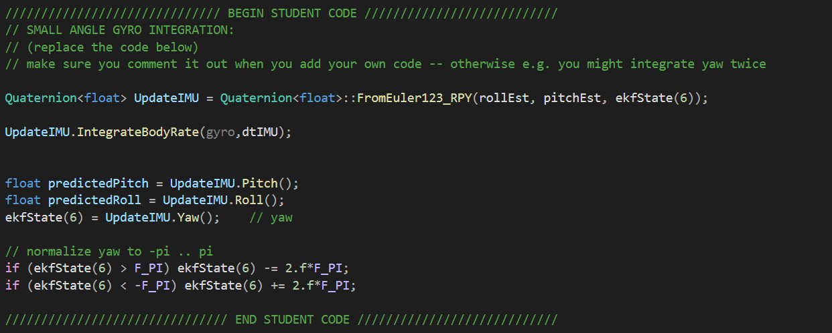



1. Predict State

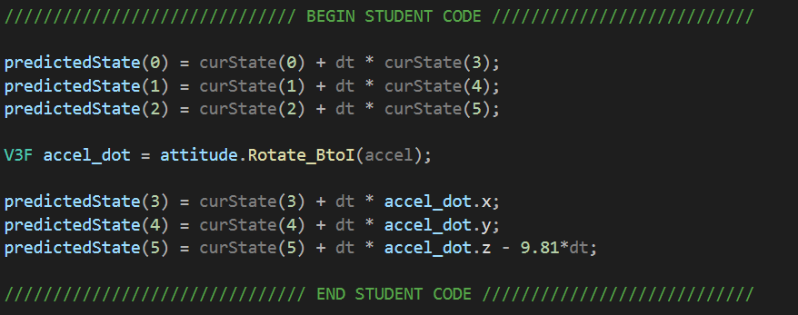

1. PredictionCov

Get Rbg Prime

From estimation of Quadrotor material eq.(52)

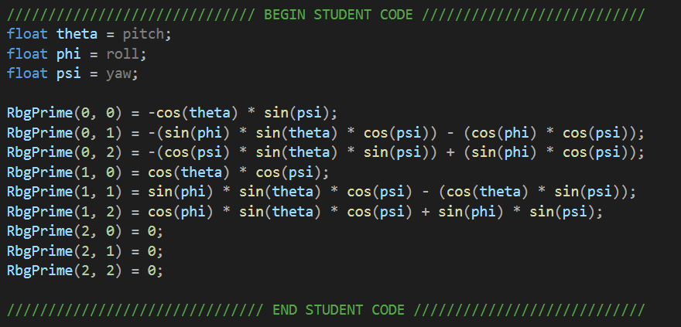

Predict

From estimation of Quadrotor material eq.(50)

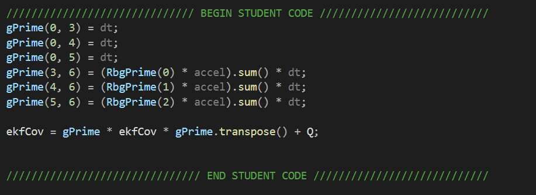

1. Update From Magnetometer

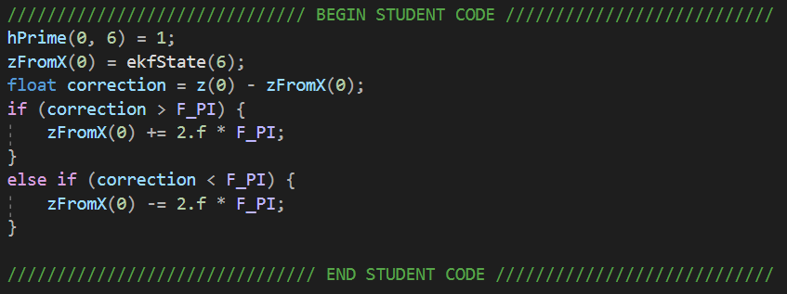

1. Update From GPS

